**Sherwood Natural Wood Effect Porcelain Paving Slabs:** 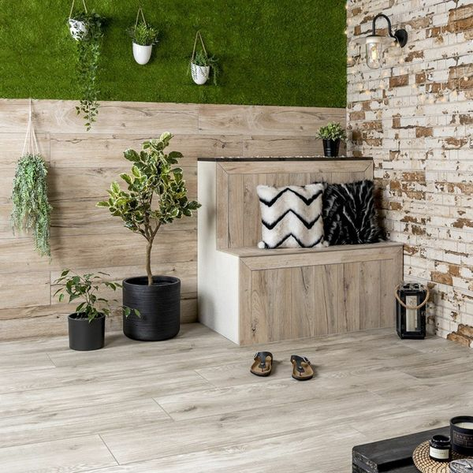

## **Product Description**

Have a look at our Sherwood Natural Wood Effect Tiles. Made from porcelain with a matt finished and a realistic wood grain finish, these tiles are perfect for outdoor use as they are 20mm thick. Our first range of external 20mm porcelain; perfect for a low maintenance decking area in your garden. Abundant with the natural knots and grain of real wood flooring available in 3 great shades, be it more contemporary greys or natural oaky wood, our Sherwood collection harmoniously works with all things outdoors.

Have you tried our [20mm Paving Slab Trims](https://www.wallsandfloors.co.uk/20mm-paving-slab-trims)? **What's special about these tiles?**

> Gorgeous natural wood colour

> Seamless appearance with wooden inspiration to create a natural space

> R11 anti-slip

> Durable porcelain, suitable for outside

**Have you seen our selection of Norcross Rock-Tite products? They're perfect for fixing and completing outdoor projects!**

## **Product INFO**

* Product ID: 44426
* Tiles Per SQM: 2.8366782497695
* Sale by: Per SQM
* Size: 295x1195x20mm
* Weight: 15.60 KG
* Material Type: Porcelain
* Finish: Matt
* Colour: Beige/Ivory
* Suitability: Floors
* Area Of Usage: External
* Rectified Edge: No
* Underfloor Heating: Yes
* Anti Slip Grade: R11 / 35 Degrees
* Document: [20mm Installation Guide](https://m2.wallsandfloors.co.uk/media/amasty/amfile/attach/20mm-installation-guide_4.pdf),[Cleaning and Protection Guide](https://m2.wallsandfloors.co.uk/media/amasty/amfile/attach/ltp_-_walls_floors_-_external_porcelain_-_cleaning_and_protection_guide_-_april_2020.pdf)
* Thickness (mm): 20